Name: _______________________________________________
Higher Unit 1 topic test
Date:
Time: 50 minutes
Total marks available: 48
Total marks achieved: ______

Questions
Q1.
Using the information that
6.7 × 52 = 348.4
find the value of
(i) 6.7 × 520
...........................................................
(ii) 67 × 0.52
...........................................................
(iii) 3484 ÷ 5.2
...........................................................
(Total for Question is 3 marks)

Q2.
Nick has 2 cars.
Car A uses petrol.
Car B uses diesel.
Petrol costs £1.39 per litre.
Diesel costs £1.47 per litre.
The table below shows the average distance that Nick can drive each car using 1 litre of fuel.
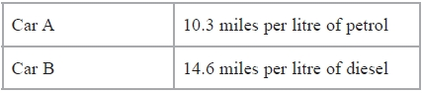
Nick is going on a journey in one of his cars.
The distance Nick is going to drive is 450 miles.
Work out the difference of the total costs of the fuel for the 2 cars for this journey.
£...........................................................
(Total for question = 4 marks)

Q3.
Work out an estimate for 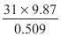

..............................................................................................................................................
(Total for Question is 3 marks)

Q4.
Margaret has some goats.
The goats produce an average total of 21.7 litres of milk per day for 280 days.
Margaret sells the milk in ½ litre bottles.
Work out an estimate for the total number of bottles that Margaret will be able to fill with the milk.
You must show clearly how you got your estimate.

..............................................................................................................................................
(Total for Question is 3 marks)

Q5.
Write down the value of
(i) 7°
..............................................................................................................................................
(ii) 5⁻¹
..............................................................................................................................................
(iii) 9^{½}
..............................................................................................................................................
(Total for Question is 3 marks)
Q6.
(a) Write down the value of 10⁰
...........................................................
(1)
(b) Write down the value of 10⁻²
...........................................................
(1)
(c) Write these numbers in order of size.
Start with the smallest number.
2.73 × 10³ 27.3 × 10⁻³ 273 × 10² 0.00273
...........................................................
(2)
(Total for Question is 4 marks)

Q7.
(a) Simplify 5⁴ × 5⁶
...........................................................
(1)
(b) Simplify 7⁵ ÷ 7²
...........................................................
(1)
(Total for Question is 2 marks)

Q8.
Write 525 as a product of its prime factors.

..............................................................................................................................................
(Total for Question is 3 marks)

Q9.
There are 17 men and 26 women in a choir.
The choir is going to sing at a concert.
One of the men and one of the women are going to be chosen to make a pair to sing the first song.
(a) Work out the number of different pairs that can be chosen.
...........................................................
(2)
Two of the men are to be chosen to make a pair to sing the second song.
Ben thinks the number of different pairs that can be chosen is 136
Mark thinks the number of different pairs that can be chosen is 272
(b) Who is correct, Ben or Mark?
Give a reason for your answer.
.............................................................................................................................................
.............................................................................................................................................
(1)
(Total for question = 3 marks)
Q10.
Marie has 25 cards.
Each card has a different symbol on it.
Marie gives one card to Shelley and one card to Pauline.
(a) In how many different ways can Marie do this?
...........................................................
(2)
There are 12 boys and 10 girls in David's class.
David is going to pick three different students from his class and write their names in a
list in order.
The order will be

(b) How many different lists can David write?
...........................................................
(3)
(Total for question = 5 marks)

Q11.
Work out the value of (7.5 × 10⁴) × (2.5 × 10³)
Give your answer in standard form.
...........................................................
(Total for Question is 2 marks)

Q12.
An object is travelling at a speed of 2650 metres per second.
How many seconds will the object take to travel a distance of 3.45 × 10¹⁰ metres?
Give your answer in standard form, correct to 2 significant figures.

. . . . . . . . . . . . . . . . . . . . . . seconds
(Total for Question is 3 marks)

Q13.
(a) Write down the value of 10^{–1}

..............................................................................................................................................
(1)
(b) Find the value of

..............................................................................................................................................
(2)
(c) Write in the form k , where k is an integer.

..............................................................................................................................................
(2)
(Total for Question is 5 marks)

Q14.
(a) Rationalise the denominator of
...........................................................
(2)
(b) Work out the value of (√2 + √8)²
...........................................................
(2)
(Total for Question is 4 marks)
Examiner's Report
Q1.
Many students were able to score at least 1 mark in this question, usually in part (i), but few were able to score all 3 marks. A significant number of students attempted to evaluate the calculations by long multiplication/division rather than by relocating the positions of the decimal points in the given information. Students should be advised to estimate the values of calculations as a guide to determining the positions of decimal points in given information.

Q2.
There were many misconceptions with this question, and much misunderstanding about rates. Most understood the need to use multiplication or division as operators, but regularly confused these, not always recognising that the result of their calculations did not make sense in the given context. Many students failed to understand the relationship of miles to litres, and failed to identify the distance of 450 miles from the question. By far the biggest failing was inappropriate rounding, with amounts of money truncated rather than being rounded to the nearest penny. As a result many got near to, but failed to reach, the accurate answer.

Q3.
Those candidates who attempted to obtain the answer through calculation and not rounding were awarded zero marks. Most candidates used numbers such as 30, 10 or 0.5 and gained a mark through realising that simplified numbers were needed. Having worked out a simplified numerator, many candidates then appeared to be confused as to what to do with their 0.5, many multiplying by 0.5 or dividing by 2 to get 150. It was unusual to see candidates stating that they wanted to calculate 300 ÷ 50; they more usually gave an incorrect answer arising from these two numbers.

Q4.
Candidates were presented with two challenges in this question. Firstly, they had to decide on the calculations needed to work out the number of bottles that could be filled with milk and secondly, to find an estimate of this. Most candidates gained some credit for their responses, usually for identifying an appropriate calculation. However, the number of candidates who took the easiest route to find an estimate, ie to round values correct to one significant figure then work out 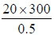 , was relatively small. Instead many candidates either failed to round any of the quantities or rounded only one of the quantities, usually 21.7 to 22. As a result they made calculations more onerous and prone to error. Division by 0.5 was confused with dividing by 2. This question clearly identified an area where candidates would benefit from more practice.

Q5.
In part (i) 7 and 0 were the most common incorrect responses.
In part (ii) many candidates did not know how to deal with the negative index. The most common incorrect response was –5.
In part (iii) This part proved to be the most challenging with only 34% providing correct answers.

Q6.
Parts (a) and (b) were essentially knowledge based For part (b) a few candidates left their answer as ¹⁄₁₀². This was not awarded the mark.
For part (c), candidates were expected to adopt one of two strategies. The first was to reduce each of the given numbers to an ordinary number and them compare sizes. If a candidate did the conversion correctly for at least 1 number, they were awarded the method mark. The second strategy, much more rarely seen, was to write each number in standard form. If a conversion was done correctly for at least one number then the method mark was awarded.
Many candidates, however, did not show what they had done and went straight to writing down the 4 given numbers.

Q7.
This question was done well. The vast majority of candidates were able to simplify the given calculations and give their answers in a suitable form. Common incorrect answer were 5²⁴ and 7^{2.5}.

Q8.
Most candidates used the factor tree method in their responses to this question. Though candidates appeared to understand what they needed to do, regrettably many of their attempts were spoiled by their inability to find correct pairs of factors, that is, they were let down by weak arithmetic. Candidates who completed the factor tree diagram successfully sometimes listed the prime factors but did not express their answer as a product so could not be awarded the mark assigned for a fully correct answer. "1" was sometimes included as a prime factor.

Q9.
No Examiner's Report available for this question

Q10.
No Examiner's Report available for this question

Q11.
There was usually some evidence of the correct calculation being performed, but frequent errors in writing the answer correctly as required. The most common error was in writing the answer as 18.75 x 10⁷. A few candidates attempted to add the given numbers rather than multiply.

Q12.
Nearly all candidates correctly interpreted the speed aspect of the problem and attempted to divide distance by speed. The problem for most was taking their calculated result and putting it in standard form notation. It was clear that the calculator was rarely being used to best effect in producing the final standard form answer.

Q13.
Part (a) was well attempted but as many candidates scored B1 as scored B0. Common errors included rewriting the value in the question or writing 0.01.
Part (b) was well attempted but few gained M1A1. Those that gained M1 usually earned the mark for = 3. Other common errors included 27 ÷ 3 × 2 or writing 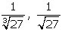 or 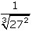. Part (c) was well attempted by most candidates but few achieved full marks. Many split 75 correctly as 25×3 but did not write the square root sign or often wrote 25 so achieved M0A0. A few candidates split 75 as 15 × 5.

Q14.
Part (a) was done correctly by those candidates who understood the standard process of rationalisation. Answers in any correct form, such as 4√3 or √48 were accepted for full marks. If candidates went on to attempt to simply their answer and gave a subsequent incorrect answer then they were not awarded the final A mark.
Some candidates think that they can rationalise the denominator of the fraction by squaring the top and squaring the bottom presumably under a misapprehension that they are dealing with equivalent fractions.
Part (b) required candidates to expand the square – in many cases this proved too much, with many cases of the equivalent of a² + b². The use of a² + 2ab + b² was rarely used even by successful candidates. Some could expand the brackets correctly, but could not see how to simplify their square roots so unsimplified answers such as 10 + 2√16 were seen. Many went on to 'simplify' wrongly, giving answers such as √32

Mark Scheme
Q1.
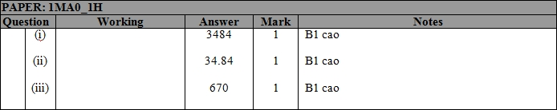

Q2.
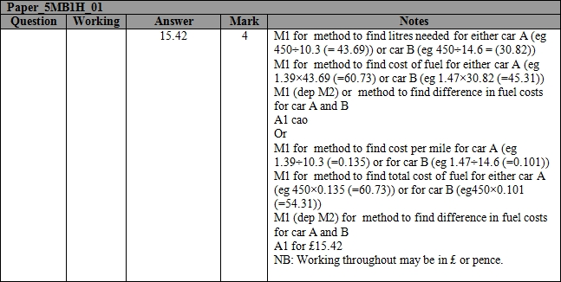

Q3.
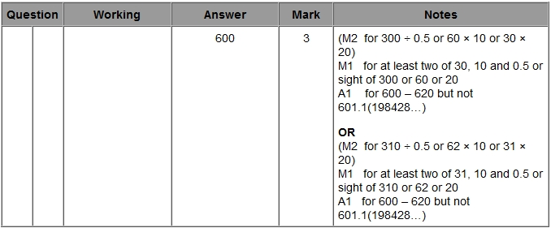

Q4.
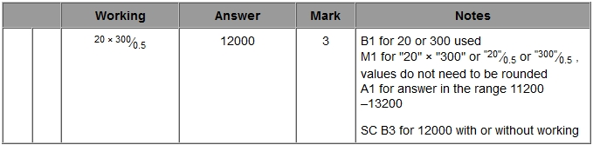

Q5.
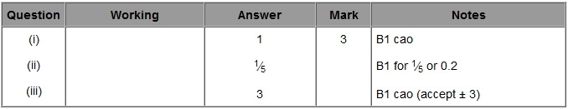

Q6.
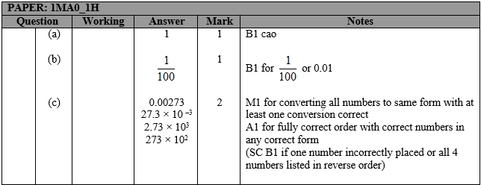

Q7.
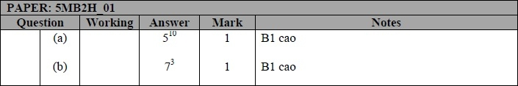

Q8.
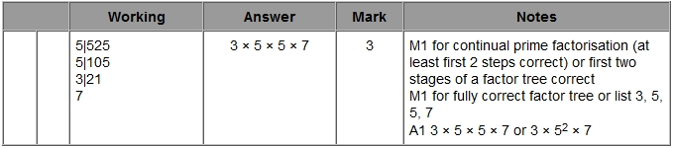

Q9.
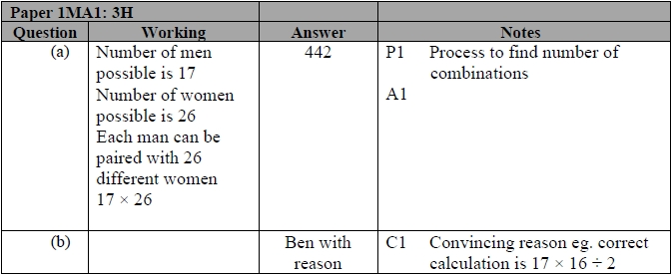

Q10.
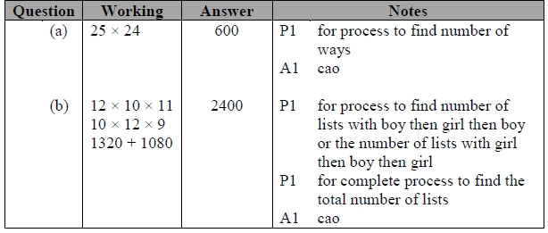

Q11.
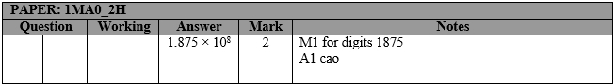

Q12.
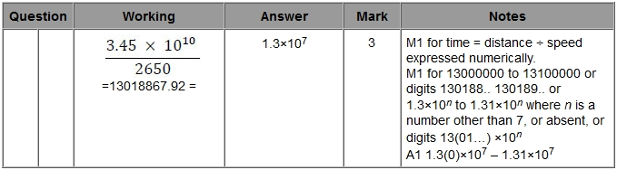

Q13.
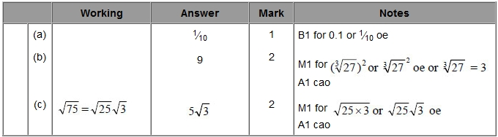

Q14.
